Ref:NCCS/CIR-08/PRI/ JAN/2025 DOI: DEC 30.2024
Newsletterforthemonthof JAN’25
 | Date: JAN 2 New Year Celebration Day: Thursday  Aim: New year- eve celebration is celebrated with their peers and teachers on this day in school. Student’s share their wishes among their friends and teachers and enjoy by performing dance and events. This is to bring a joyful year ahead in everyone’s life.  Organizer: PRIMARY COMPARTMENT
 | Date : JAN 4 FDP on NEP Day: Saturday  (AF :3.30pm to 5.00pm)  Aim: The faculty development programme aims to enhance teaching skills and subject knowledge among educators. Which helps them to add new modern techniques in classroom environment to bring students skills.  Organizer: NCCS
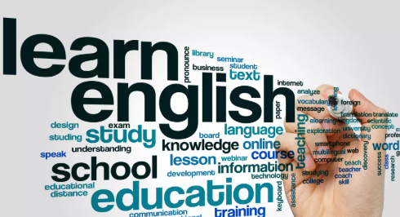 | Date : JAN 6 ENGLISH SEMINAR Day: Monday  Aim: Seminar provides a platform for the participants to discuss innovative ideas to the given topics. We encourage our students prepare themselves to make them strong enough to deliver their ideas in English.  Organizer: ENGLISH DEPARTEMNT
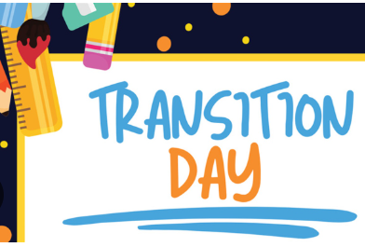 |  | Date: JAN 7 TRANSITION ORIENTATION Day: Tuesday  Aim: Our school implements a transition programme to assist the students in acclimating to their new surroundings. Parents and Students from Grade(M3 to 1) are addressed in this programme to help their children move to the new curriculum.  Organizer: MONTE-PRIMARY COMPARTMENT
 |  | Date: JAN 8 TRANSITION ORIENTATION Day: WEDNEsday  Aim: A well-designed transition programme eases the shift from academics’ studies in upgrading the grade level. Parents of Grade4 are invited for transition of their child to Grade5.  Organizer: PRIMARY–MIDDLE COMPARTMENT
 |  | Date: JAN 8 TRADTIONAL PERIOD Day: Wednesday  Aim: Education during traditional period often centered on oral storytelling and apprenticeship. It leads to better understanding of concepts by detailing with tutor.  Organizer: HINDI DEPARTMENT
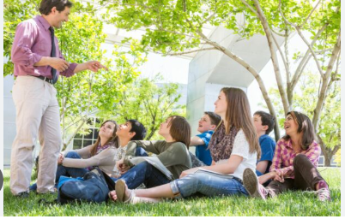 |  | Date: JAN 9 OUTDOOR TEACHING Day: Thursday  Aim: Many educators find that outdoor teaching enhances student engagement and curiosity in learning the ideas easily by moving out of classrooms. It allows you to implement the logics with outside the context.  Organizer: Maths Department
 |  | Date: JAN 9 OUTDOOR TEACHING Day: Thursday  Aim: Outdoor teaching provides students with hands-on learning experiences in a natural environment. As a part of learning social studies outdoor it visualizes the content with reality.  Organizer: Social Department
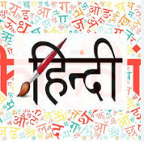 |  | Date : JAN 10 HINDI DIWAS Day: Friday  Aim: The significances of Hindi Diwas lies in fostering pride in our national language and cultural heritage. To bring the specialty of our national language , we engage our students to prepare them to deliver speech in Hindi.  Organizer: Hindi Department
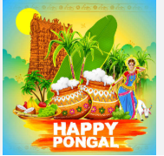 |  | Date: JAN 10 PONGAL CELEBRATION Day: Friday  Aim: Pongal festival symbolize gratitude towards nature for a bountiful harvests. We at NCCS gather together to celebrate this eve with great joy and worship to GOD of Sun, with many events followed to make remarkable memories among our students.  Organizer: NCCS
 |  | Date: JAN 10 CLUB CARNIVAL Day: Friday  Aim: The annual club carnival brought students together from all compartments to showcase their talents and activities done through the club period. As a there 9 clubs each set their benchmark to bring out the best out of them.  Organizer: NCCS-CLUBS
 |  | Date: JAN 10 CAREER COUNSELLING Day:Fri day  Aim: Career counselling is crucial for helping professionals navigate the rapidly changing job market. To bring out various support additional to teaching there is a career counselling scheduled on this day.Career counseling for teachers (3.30pm-5.00Pm).  Organizer: CLD
 |  | Date: JAN11to16 FESTIVAL HOLIDAYS  Aim: A festival holiday refers to a break or vacation associated with the celebration of Pongal with kith and kins. To enjoy the festival of harvest with families far and near and loved ones.  Organizer: NCCS
 |  | Date: JAN 20 ROAD SAFETY AWARENESS DAY: Monday  Aim: Spreading awareness through campaigns, education programme and community outreach will help in avoiding accidents and to learn traffic rules and laws. It helps to educate people to know about the practices and reduced risks of traffic-related incidents.  Organizer: SAFETY AND SECURITY CELL
 |  | Date: JAN 26 REPUBLIC DAY CELEBRATION DAY: Sunday  Aim: January 26th marks the day when the constitution of India came into effect in 1950, turning India into a republic. It’s one of the country’s most significant holidays. We at NCCS celebrate this significance through online mode (Flag Hoisting at School -offline).  Organizer: Middle Compartment, Best Practice Cell
LIST OF HOLIDAYS
- January 11 to 19 - Pongal Holidays
- January 25 - 4th Saturday

Note:Pleasefilethisforfuturereference.
Kindly visit www.nandhacityschool.org to see colorful newsletter.

Vanathi K A G Prakash Nair
Co-Ordinator Principal

