NANDHA CENTRAL CITY SCHOOL
Give us a child
Take back a leader

www.nandhacityschool.org

Ref: NCCS /P/ CIR09/FEBRUARY/ 2023-24 DOI: JANUARY 31, 2024

Newsletter for the Month of FEBRUARY 2024

Greetings from NCCS!
As we embark on the month of February, we are thrilled to bring you a vibrant array of educational initiatives that reflect our commitment to holistic learning and continuous improvement. This newsletter serves as a window into the exciting happenings at our school, highlighting key events and programs scheduled for this month.
OPEN DAY
DATE: FEBRUARY 03, 2024 DAY: SATURDAY

AIM: To foster a strong sense of collaborative environment that nurtures the
educational journey of our students.
Objectives: *Facilitate meaningful interactions between parents and teachers.
*Showcase the achievements and progress of our students.
*Provide insights into our curriculum and teaching methodologies.
. Organiser: Primary Compartment
FACULTY DEVELOPMENT PROGRAM
DATE: FEBRUARY 03, 2024 DAY: SATURDAY

AIM: To enhance the professional growth of our educators, ensuring they stay updated
with the latest teaching methodologies and innovations.
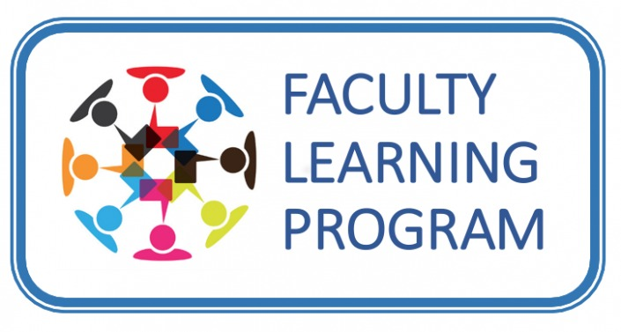
Objectives: *Provide targeted training sessions on effective teaching strategies.
*Encourage collaboration and the exchange of best practices.
*Equip teachers with tools to adapt to evolving educational landscapes.
Oganiser: NCCS
INNOVATION DAYS
DATE: FEBRUARY 09, 10, 11, 2024 DAY: FRIDAY - SUNDAY

AIM: To celebrate and encourage a culture of innovation among students, raising
creativity and problem-solving skills.
Objectives: *Showcase student projects that demonstrate creativity and
innovation.
*Inspire students to think critically and embrace a growth mindset.
*Encourage collaboration and teamwork in innovative endeavors.
. Organiser: Nandha Institutions
FINANCIAL WORKSHOP BY CBSE FOR TEACHERS
DATE: FEBRUARY 09 , 2024 DAY: FRIDAY

AIM: To empower teachers with financial literacy knowledge, enabling them to instill
essential financial skills in students.
Objectives: *Equip teachers with a solid understanding of financial concepts.
*Provide resources to integrate financial literacy into the curriculum.
*Promote a financially aware and responsible school community.
. Organiser: NCCS
TRADITIONAL TEACHING
DATE: FEBRUARY 12, 2024 DAY: MONDAY

AIM: To uphold the importance of traditional teaching methods and ensure a strong
foundation in English language skills.
Objectives: *Emphasize the value of foundational language skills.
*Incorporate classic literature and language-building activities.
*Cultivate effective communication and critical thinking.
. Organiser: English Department
OUTDOOR TEACHING
DATE: FEBRUARY 12, 2024 DAY: MONDAY

AIM: To promote experiential learning by connecting theoretical concepts with real-
world experiences.
Objectives: *Provide hands-on experiences in outdoor settings.
*Foster a deeper understanding of the environment and social
structures.
*Encourage students to apply classroom knowledge to real-life
situations.
Organiser: EVS and Social Department
STUDY TOUR
DATE: FEBRUARY 14, 15, 16, 2024 DAY: WEDNESDAY TO FRIDAY

AIM: To broaden students' perspectives by providing real-world exposure and
enriching their academic experience.
Objectives: *Facilitate experiential learning in diverse environments.
*Improve a sense of curiosity and cultural appreciation.
*Create lasting memories and connections among students.
Organiser: NCCS

Competitive Exam

S.NO | EXAM DATE | NAME OFTHE EXAM
1. | 15.02.2024 | STUDENT DEVELOPMENT SOCIETY (NATIONAL HANDWRITING AND COLOURING CONTEST)
2. | 22.02.2024 | PROCOM OLYMPIAD
3. | 27.02.2024 | ALPHABET OLYMPIAD

Holidays in the Month

FEBRUARY 10 | II Saturday
FEBRUARY 24 | IV Saturday

We look forward to an enriching and engaging month ahead, filled with opportunities for learning, growth, and celebration.
Note: Please file this for future reference.
Kindly visit www.nandhacityschool.org to see colorful newsletter.

VANATHI.K PRAKASH NAIR A.G
COORDINATOR PRINCIPAL

