Ref: NCCS / CC /P/ CIR-09/FEBRUARY/ 2023-2024 DOI: Feb 01, 2024

Newsletter for the month of February ‘24

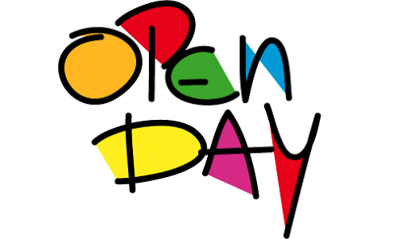 |  |  | Open Day  Date: Feb 03 Day: Saturday  Aim: An Open Day is the meeting between the parents and teachers of students to discuss a child’s progress at school and find solutions to academic or behavioural problems.  Organiser : Montessori Compartment.
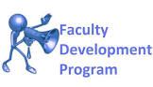 |  |  | Faculty Development Program  Date: Feb 03 Day: Saturday  Aim: The programme's goal is to improve the academic and intellectual environment in the institution by giving faculty members ample chances to do research and take part in seminars, conferences, and workshops. Faculty members' research and teaching abilities would be upgraded through participation in such a programme.  Timings:1.00PM to 3.00PM
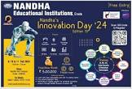 |  | Innovation Day ‘24  Date: Feb 9,10,11 Day: Friday to Sunday  Aim: Nandha Engineering College’s 13th Innovation Day will take place from Feb 9-11,2024 from 10AM-4PM at the Nandha Tech Campus. this event will provide school students with the opportunity to explore their technological and scientific skills.  Organiser: Nandha Institutions.
Study Tour
Date: Feb 15 Day: Thursday
Aim: Study Tour provide an opportunity for kids to spend time with each other in a different environment. They discuss their experiences which help them connect more. An educational tour places the students in different socio-cultural environments where they encounter new people and witness regional practices. The study tour is arranged by school management to give students an engaging learning experience and to build strong relationships with their peers.
Organiser: Montessori Compartment

Holidays in February

Feb 10 | II Saturday
Feb 24 | IV Saturday

Note: Please file this for future reference.
Kindly visit www.nandhacityschool.org to see colourful newsletter.

CO-ORDINATOR PRINCIPAL
YEAR OF INNOVATION 2015-2016

YEAR OF INNOVATION 2015-2016

T.ROOBHA A.G.PRAKASH NAIR

