NANDHA CENTRAL CITY SCHOOL
Give us a child
Take back a leader
www.nandhacityschool.org

Ref: NCCS /P/ CIR08/JANUARY/ 2023-24 DOI: DECEMBER 30, 2023

Newsletter for the Month of JANUARY 2024

Engaging Minds, Inspiring Moments! Greetings from NCCS!

As we step into the New Year, 2024 we're thrilled to share the lineup of events awaiting us in January. Here's what's ahead
SCHOOL REOPENS
DATE: JANUARY 02, 2024 DAY: TUESDAY

AIM: School bells are ringing loud and clear; Vacations over school is here"
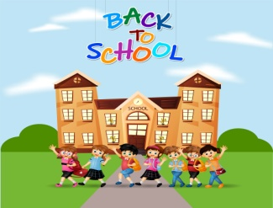
School reopens after the winter holidays.
TRADITIONAL TEACHING
DATE: JANUARY 03, 2024 DAY: WEDNESDAY

AIM: Traditional Teaching: Get ready for an immersive experience as our students
delve into the traditional teaching methods of Hindi, embracing our cultural
roots.
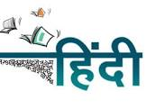
Oganiser: Hindi Department
OUTDOOR TEACHING
DATE: JANUARY 03, 2024 DAY: WEDNESDAY AIM: Outdoor Teaching: Learning extends beyond the confines of the classroom!
Join us as students explore the wonders of Math and Science in an outdoor
setting, fostering hands-on understanding.
Organiser: Math & Science Department
CAREER COUNSELING
DATE: JANUARY 06, 2024 DAY: SATURDAY

AIM: "Living Above the Line": Teachers, get ready for an enlightening session
exploring how our thinking shapes our experiences, aiming for a positive
educational journey.
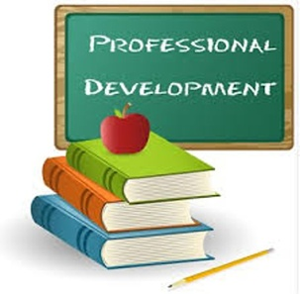
Organiser: NCCS
M3 ORIENTATION PROGRAMME
DATE: JANUARY 09, 2024 DAY: TUESDAY

AIM: M3 to Grade 1: Welcoming new students with open arms, our orientation program
will ensure a smooth transition from M3 to Grade 1.
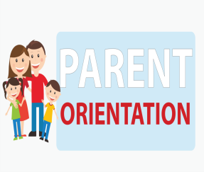
Organiser: Montessori & Primary Compartment
VISWA HINDI DIWAS
DATE: JANUARY 10, 2024 DAY: WEDNESDAY

AIM: Hindi Department Competition: Our Hindi Department is gearing up for an
exciting competition, igniting creativity and language skills among our young
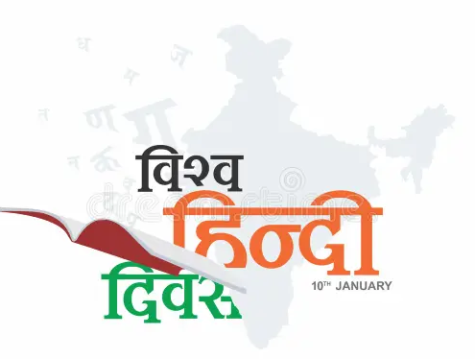 linguists.
Organiser: Hindi Department
PONGAL CELEBRATION
DATE: JANUARY 12, 2024 DAY: FRIDAY
AIM: Join us in celebrating the joyous festival of Pongal, embracing our diverse
cultural tapestry..
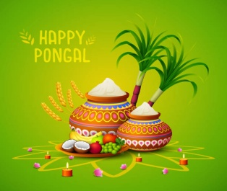
Organiser: Montessori Compartment, Promotion & Reach Cell
REPUBLIC DAY CELEBRATION
DATE: JANUARY 26, 2024 DAY: FRIDAY
AIM: Commemorating the spirit of unity, we'll honor Republic Day with pride and
patriotism.
Organiser: Middle Compartment

Revision and Assessment Dates

Name of the Assessment | Revision Dates |  | Dictionary Usage & Open Book Test | Assessment Dates
 | From | To |  | From | To
Periodic Test - 2 | Jan 18 (Thursday) | Jan 20 (Saturday) | Jan 18 (Thursday) | Jan 22 (Monday) | Jan 31 (Wednesday)
OPEN DAY |  |  |  | FEBRUARY 03(Wednesday)

Competitive Exam

S.NO | EXAM DATE | NAME OFTHE EXAM
1. | 05.01.2024 | INDIAN TALENT OLYMPIAD

Holidays in the Month

JANUARY 13 | II Saturday
JANUARY 13 – JANUARY 17 | Pongal Holidays
JANUARY 26 | Republic Day Holiday
JANUARY 27 | IV Saturday

Stay tuned for more details and specific schedules for each event. Let's make January a month of learning, joy, and shared experiences.

Note: Please file this for future reference.
Kindly visit www.nandhacityschool.org to see colorful newsletter.

VANATHI.K PRAKASH NAIR A.G
COORDINATOR PRINCIPAL

